FUNDAMENTAL OF PROGRAMMING

Assignment 1

HAIDER NAWAZ

480239

**Write a C++ program to display factors of a number using for loops.**

**CODE:** [**Q no 1**](../Desktop/HAIDER/comp%20task/assignment/A1.cpp)

#include<iostream>

using namespace std;

int main(){

int x;

cout<<"Enter a no= ";

cin>>x;

for(int y=1;y<=x;y++){

if(x%y==0){

cout<<y<<endl;} } }

**OUTPUT:**

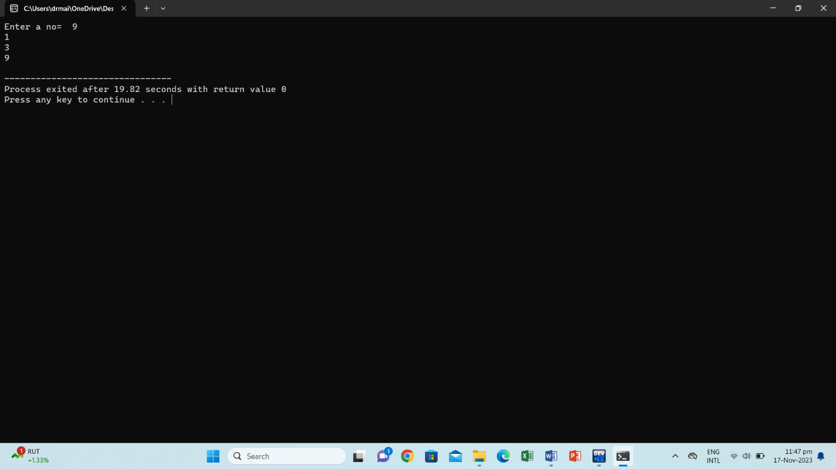

**Write output to the following code.**

**#include <iostream>**

int main() {

int x = 5;

int y = 10;

if (x == 5)

if (y == 10)

std::cout << "x is 5 and y is 10" << std::endl;

else

std::cout << "x is not 5" << std::endl;

return 0;

}

**OUTPUT:**

x is 5 and y is 10

**Write a C++ program, take an integer value from user and check if it’s greater than 10 and less than equal to 20. Print 1 if yes and print 0 if no. Use appropriate datatype for output.** [**Q no 3**](../Desktop/HAIDER/comp%20task/assignment/A3.cpp)

**CODE:**

#include<iostream>

using namespace std;

int main(){

int x;

cout<<"Enter no= ";

cin>>x;

if(x>10&&x<=20){

cout<<"1";}

else{ cout<<"0";} }

**OUTPUT:**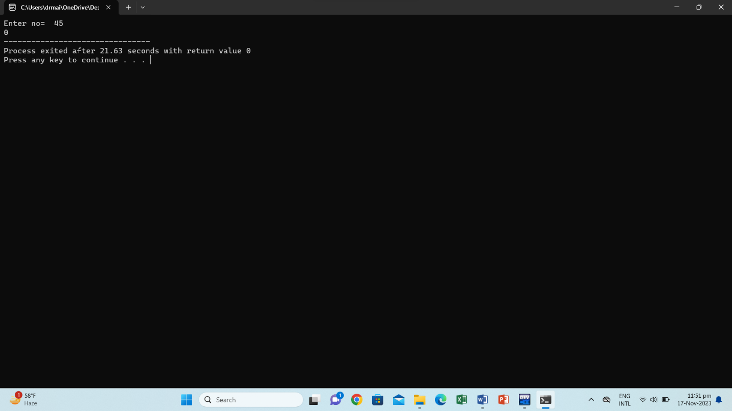

**Write a C++ program that uses a while loop to find the largest prime number less than a given positive integer N. Your program should take the value of N as input from the user and then find the largest prime number less than or equal to N. You are not allowed to use any library or pre-existing functions to check for prime numbers.** [**Q no 4**](../Desktop/HAIDER/comp%20task/assignment/A4.1.cpp)

**CODE:**

#include <iostream>

using namespace std;

bool Prime(int number) {

if(number<=1){

return false;}

for(int i=2;i*i<=number;i++) {

if(number%i==0){

return false;} }

return true;}

int main(){

int x;

cout<<"Enter a positive integer X: ";

cin>>x;

while(x>=2){

if(Prime(x-1)){

cout<<"The largest prime number less than " <<x<<" is: " <<x-1<<endl;

break;}

x--;}

return 0;}

**OUTPUT:**

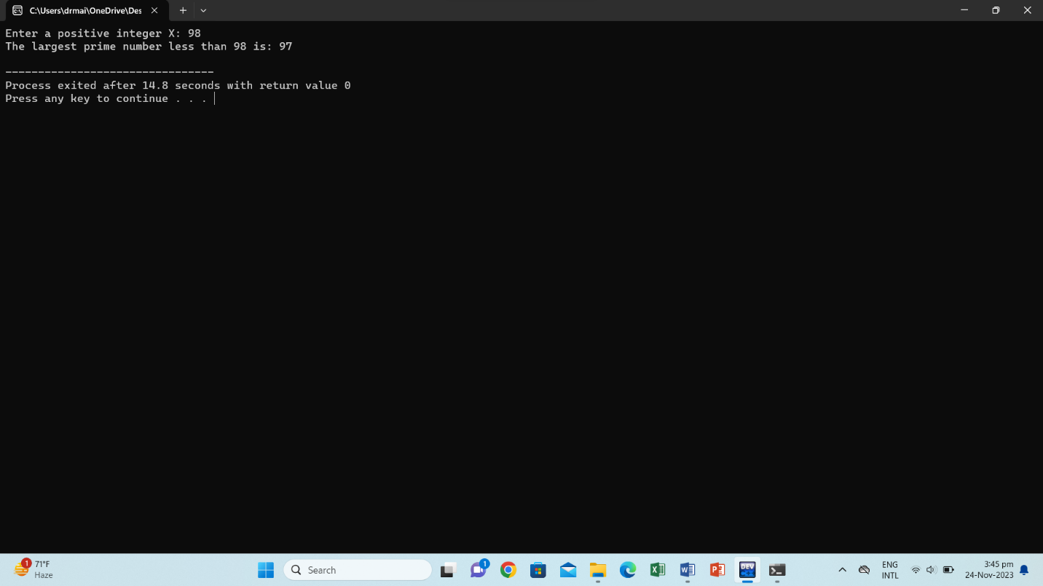

**Write a C++ program, take two string as input from user and check if both strings are equal or not. If they are equal make them unequal by rotating string. e.g., Hello is turned into olleH etc.** [**Q no 5**](../Desktop/HAIDER/comp%20task/assignment/A5.cpp)

**CODE:**

#include <iostream>

#include <string>

using namespace std;

int main(){

string str1, str2;

cout<< "Enter the first string: ";

getline(cin, str1);

cout<< "Enter the second string: ";

getline(cin, str2);

if(str1==str2){

cout<< "The strings are equal. Rotating to make them unequal.\n";

int length=str2.length();

for(int i=0;i<length/2;i++) {

swap(str2[i],str2[length-i-1]); }

cout<<"Both strings are equal so unequal them. "<<endl;

cout<< "First string " <<str1<<endl;

cout<< "Second string " <<str2<<endl;

} else {

cout<< "The strings are already unequal.\n"; }

return 0; }

**OUTPUT:**

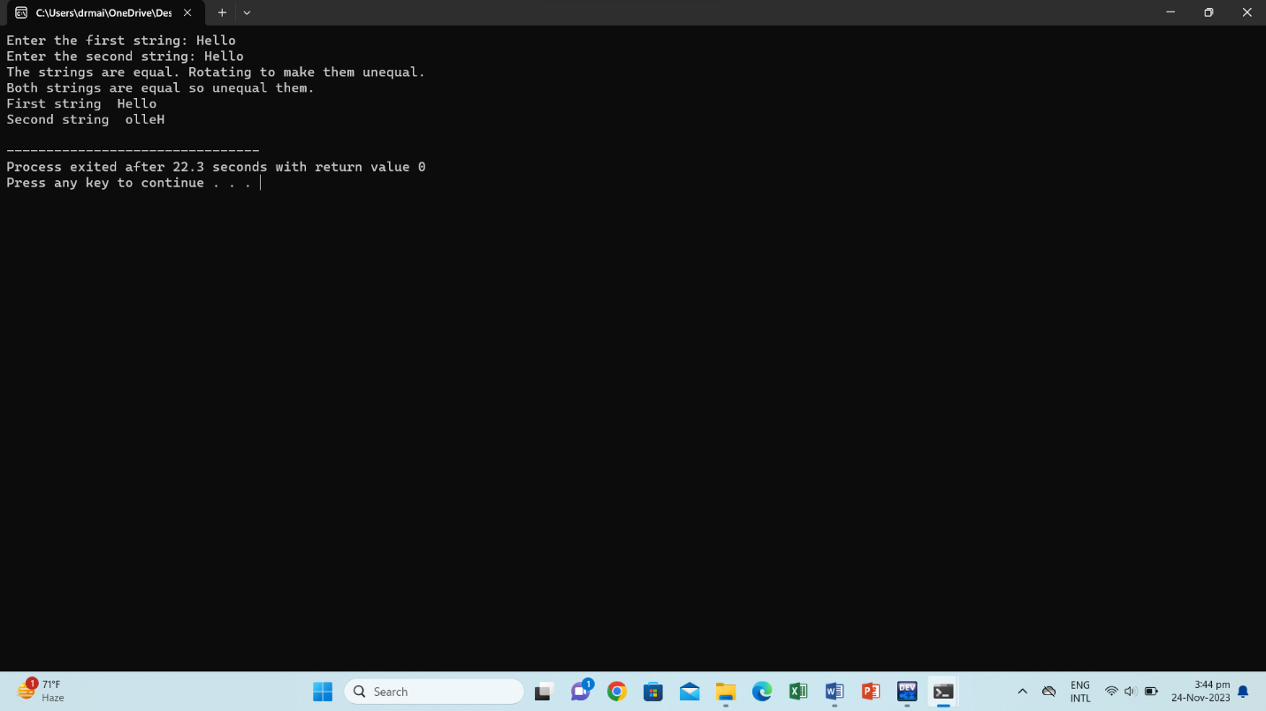

**Perform division in C++ without / using for loops. You can use / only to display the final results. Your dividend must be greater than divisor.** [**Q no 6**](../Desktop/HAIDER/comp%20task/assignment/A6.cpp)

**CODE:**

#include<iostream>

using namespace std;

int main(){

int dividend= 30;

int divisor=5;

int quotient=0;

while(dividend>=divisor){

dividend-=divisor;

quotient++;}

cout<<"Division: "<<quotient<<endl;}

**OUTPUT:**

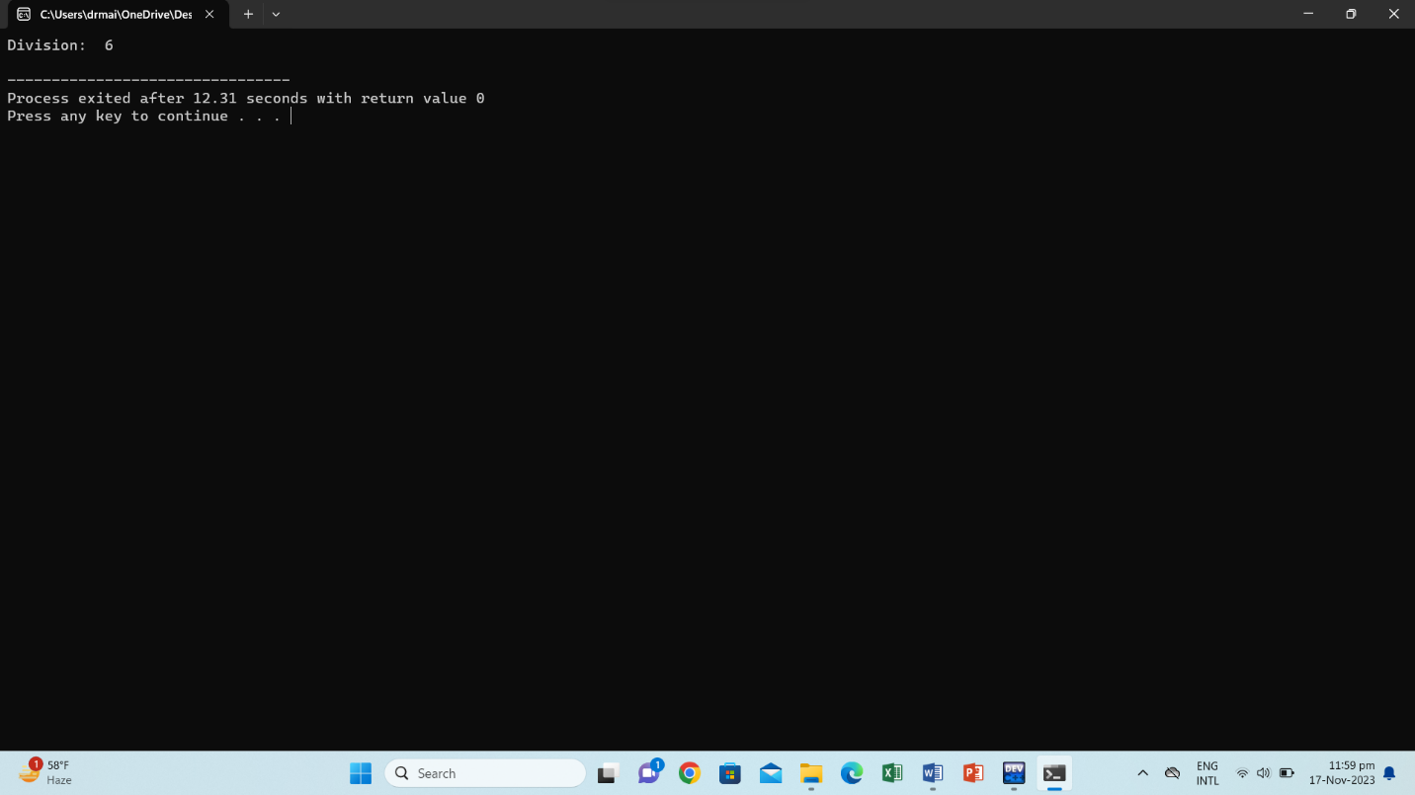

**Write a C++program for a string which may contain lowercase and uppercase characters. The task is to remove all duplicate characters from the string and find the resultant string.** [**Q no 7**](../Desktop/HAIDER/comp%20task/assignment/A7.cpp)

**CODE:**

#include<iostream>

using namespace std;

int main(){

string str1,str2;

cout<<"Enter the word ";

cin>>str1;

int j=0 , i=0;

for( i=0; i<str1.length();i++){

for(j=0;j<str1.length();j++){

if(str1[i]==str1[j]){

break;} }

if(i==j){

str2+=str1[i];} }

cout<<str2;

return 0;}

**OUTPUT:**

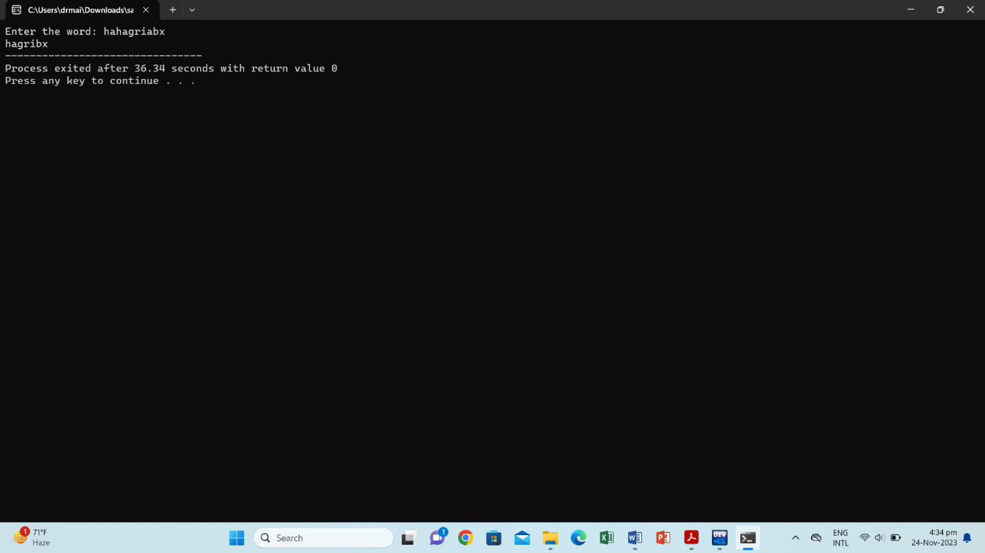

**Suppose an integer array a[5] = {1,2,3,4,5}. Add more elements to it and display them in C++.** [**Q no 8**](../Desktop/HAIDER/comp%20task/assignment/A8.cpp)

**CODE:**

#include<iostream>

using namespace std;

int main(){

int a[5]={1,2,3,4,5};

int A[7]={1,2,3,4,5,6,7};

for(int x=0;x<7;x++){

cout<<A[x]<<" , ";

}

}

**OUTPUT:**

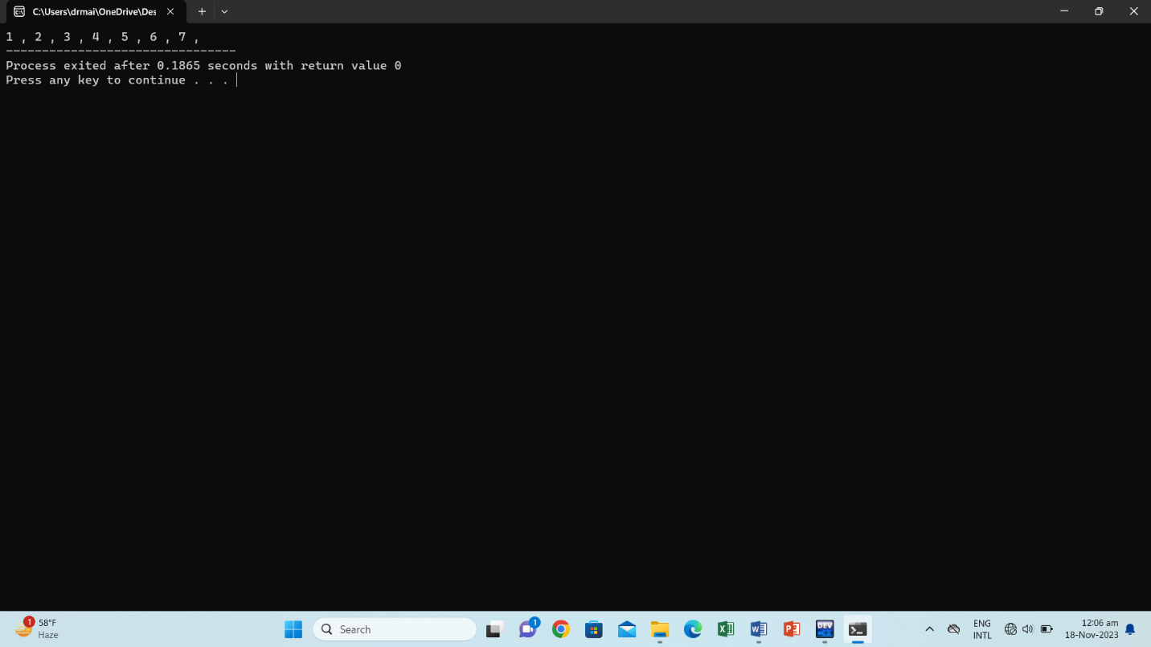

**Given an integer array and an integer X. Find if there’s a triplet in the array which sums up to the given integer X.** [**Q no 9**](../Desktop/HAIDER/comp%20task/assignment/A9.cpp)

**CODE:**

#include<iostream>

using namespace std;

int main(){

int num,x,y, sum;

cout<<"Enter the number of elements: ";

cin>>num;

int arr[num]={};

for(int i=1;i<=num;i++){

cout<<"Array no "<<i<<": ";

cin>>arr[i];}

cout<<"Array: ";

for(int j=1;j<=num;j++){

cout<<arr[j]<<" ";}

cout<<endl;

cout<<"Enter sum answer: ";

cin>>y;

for(int i=1; i<=num; i++){

for(int j=i+1;j<=num; j++){

sum = arr[i] + arr[j];

for(int k=j+1;j<=num; j++){

sum+=arr[k];

if(sum==y){

cout<<"( "<<arr[i]<<" , "<<arr[j]<<" , "<<arr[k]<<") \n";} } } } }

**OUTPUT:**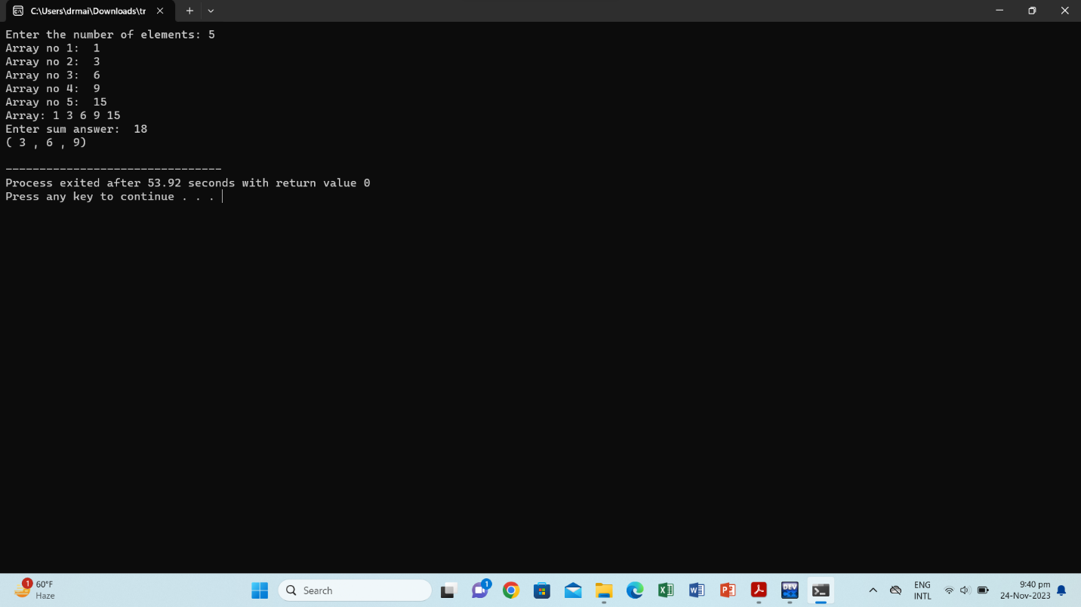

**Implement Bubble Sort on an array of 6 integers.** [**Q no 10**](../Desktop/HAIDER/comp%20task/assignment/A10.cpp)

**CODE:**

#include<iostream>

using namespace std;

int main(){

int x=6;

int arr[x]={};

for (int i = 1; i<=x; i++)

{ cout<<"Enter no"<<i<<": ";

cin>>arr[i]; }

cout<<"Ascending order: ";

for(int j=1;j<=x;j++)

{ for(int k=j+1; k<=x; k++)

{ int swap;

if(arr[j]>arr[k]){

swap=arr[j];

arr[j]=arr[k];

arr[k]=swap; } }

cout<<arr[j]<<" "; }

cout<<endl;

cout<<"Descending order: ";

for(int j=1;j<=x;j++)

{ for(int k=j+1; k<=x; k++)

{ int swap;

if(arr[j]<arr[k]){

swap=arr[j];

arr[j]=arr[k];

arr[k]=swap; } }

cout<<arr[j]<<" "; }

return 0; }

**OUTPUT:**



